**HIGH-SPEED**

**AUTOMATIC POWER FACTOR CONTROLLER**

**FOR THYRISTOR SWITCHES -TPFC-03**

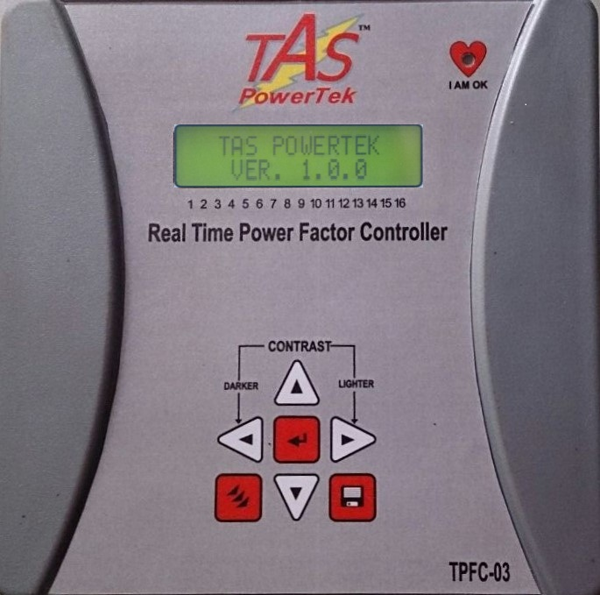

**USER MANUAL**

**NOTE**

These instructions do not purport to cover all details or variations in equipment, nor to provide for every possible contingency to be met in connection with installation, operation or maintenance.

Should further information be desired or should particular problems arise which are not covered sufficiently for the purchasers purposes, the matter should be referred to our factory.

The contents of this User Manual shall not become part of or modify any prior or existing agreement or relationship. Any statements contained herein do not create new warranties or modify the existing warranty.

The reproduction, transmission or use of this document or its contents is not permitted without express written authority. Offenders will be liable for damages. All rights are reserved.

**CAUTIONS**:

1. There are High Voltages associated with this Unit. So, take appropriate precautions.
2. To be installed & commissioned by a technically qualified person only.
3. TPFC-03 Auto. Power Factor Controller (APFC) is to be used indoor only.
4. Make sure that the Capacitor Bank Discharge time / number of line cycles set in the PF Controller matches with the actual Capacitor Bank discharge time / cycles.
5. This User Manual corresponds to the TPFC-03 Controller, Firmware Version 1.1.3

Because of continuous improvements carried out by TAS PowerTek in their Product’s Features and Specifications, the Product as well as the Content of the User Manual is likely to get updated without any prior notice.

Therefore, please always refer to the User Manual supplied to customer along with the Product, at the time of product dispatch.

**INDEX**

**Topic Page No.**

1. Index Page - - - 3

2. Ordering Information - - - 4

3. Features - - - 5

4. Specifications - - - 6

5. Mechanical Dimensions - - - 7

6. Terminal Arrangement & Connector Details - - - 8

7. Front Panel Indications & Key-Board - - - 12

8. Key-Board Description - - - 13

9. Installation Control Schematic - - - 14

10. PF correction techniques - - - 17

11. Front LCD Display - - - 19

12. Menu Structure

Expert Configuration menu - - - 22

13. Display of various parameters - - - 31

14. Auto and Manual Modes of operation - - - 34

15. Notes - - - 36

16. Commissioning Instructions - - - 37

17. Fault finding Guidelines and Troubleshooting procedures - - - 38

18. Parameters Settings - - - 39

19. Field Commissioning & Set-up Records - - - 41

20. Manufacturer’s Contact Details - - - 43

**Ordering Information**

Product Specific Information Number (PSIN): Single-Load-Current-CT based, High-Speed Automatic Power Factor Controller, with wide voltage range Input AC Operating Aux. Supply.

TPFC-03 / nn

nn Number of Current-Sourcing Transistor Output Stages, suitable for Capacitor-

Duty Thyristor Switches for Three-Phase Power Capacitors:

Standard Output Options are: 04, 08, 12, or 16.

(Similar APFC Unit is available with Relay Contact Outputs, as APFC-03. The APFC-03 Firmware is compatible for the Medium-Speed to Low-Speed PF Correction Applications with Standard, Capacitor-Duty, Three-Phase Power Contactors. Please contact TAS PowerTek, Nashik, India, for further details.)

**Features:**

1. Totally Micro-Controller based Digital Signal processing logic for measurements, monitoring, analysis and controls. Designed for applications in High-Speed, Power Factor Correction required for fast-changing loads such as, Welding Shops, Induction Furnaces, Rolling Mills, Riveting Shops, Large Reciprocating Compressor Lines, etc.
2. Wide AC Volt. I/P Supply Range SMPS, suitable for use on Nom. 50 Hz or 60 Hz.

3. Active Power Measurements with 1.0 Class accuracy, Reactive Power Measurement

with 2.0 Class accuracy, when measurement voltage & Current are from recommended

Phases.

4. Measurement and kVAr compensation are Voltage, Frequency / THD compensated.

5. Load Voltage & Load Current THD measurement with Odd Harmonic coefficient

up to 15th Harmonic.

6. Mode for switching: User defined.

7. 4 Models, as per Order Code, 04, 08, 12 or 16 Current-Sourcing Transistor Outputs

with User Provided External DC Supply of 12 Vdc or 24 Vdc. Suitable for direct

interface to Capacitor-Duty Thyristor Switches from TAS, or from others.

8. Capable of doing the kVAr measurements by averaging cycle of the mains waveform

and provide the kVAr compensation.

9. DIN Standard 144 x 144 mm Plastic Cabinet for panel-door flush-mounting. Rear side

dimensions as 137 x 137 mm with recommended Panel door cut-out as 138 x 138 mm.

Max. Depth of 76 mm on rear side of panel mounting door.

10. Protections provided (user settable):

* + Over / Under Voltage at measurement input.
  + Load Voltage and Load Current Harmonic Overload.
  + Over-Temperature inside the TPFC-03 Controller Unit.
  + Out of Capacitor Bank steps, Insufficient Total Capacitive kVAr for Compensation (only for indication)
  + Over / Under AC Mains Line Frequency.

**Specifications:**

1. Balanced 3-Phase Reactive Power Compensation because of 3-Phase Balanced Connected Power Capacitor Bank Steps, thru’ High-Speed Thyristor Switches.
2. Operating Auxiliary and Measurement voltage: 100V to 500V AC Line-to-Line or 100 Vac to 300 Vac Line-to-Neutral; with supply frequency as Nominal 50 Hz (+/-3 Hz) or 60 Hz (+/-3 Hz).
3. One Load Current Input from C.T. (from C.T. secondary): 1A or 5A, selectable at the terminal block at the rear.

4. Auxiliary Supply: Phase-to-Phase100 Vac or 500 Vac or Phase-to-Neutral 100 Vac to

300 Vac, with AC Mains Supply Frequency of Nom. 50 (+/-3) Hz or 60 (+/-3) Hz.

5. P.F. Correction time: Selectable from 3 to 3000 Line Frequency Cycles.

6. Capacitor Bank Discharge Time: Selectable from 1 to 60 seconds.

7. Interleaving delay: instantaneous switching or fixed 1 second.

8. Active Power Measurements with 1.0 Class accuracy, Reactive Power Measurement with 2.0 Class accuracy, when the measurement voltage & Current is from recommended Phases.

9. Output Commands: Max. 20 mA Current-Sourcing Transistor Outputs, using external

supply of 12Vdc / 24Vdc, Output Short-Circuit Protected.

10. Operating Ambient Temperature Range: 0 to +55o C.

11. Storage Temperature Range: 0 to +65o C.

12. Relative Humidity Range: 10% to 95%. (Non-Condensing).

13. Un-packed Net weight of the Unit: 650 grams.

**MECHANICAL DIMENSIONS:** Front Side: 152 x 152 mm, Rear Side: 137 x 137 mm.

Rear Depth: 76 mm, Panel Cut-out: 138 x 138 mm.

 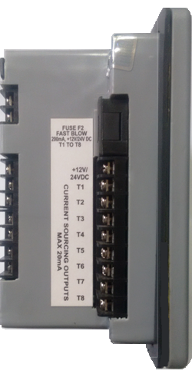

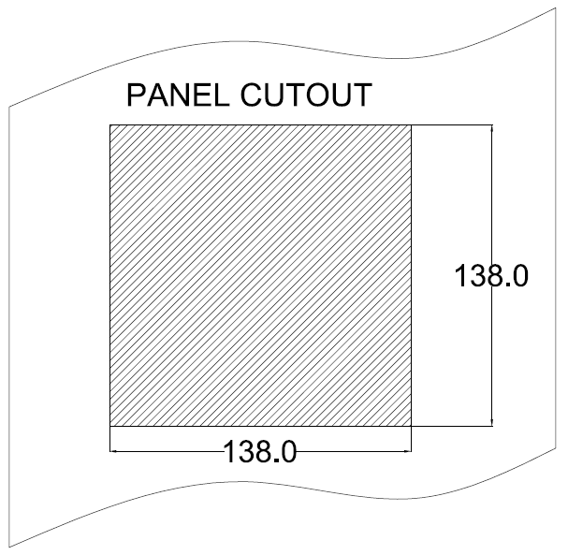

87mm

**TERMINAL ARRANGEMENT & Connector Details:**

BACK SIDE TERMINAL:

Load C.T. input

Auxiliary & Measurement Inputs, Fuse, Slow-Blow, 0.8 Amps, 250 VAC.

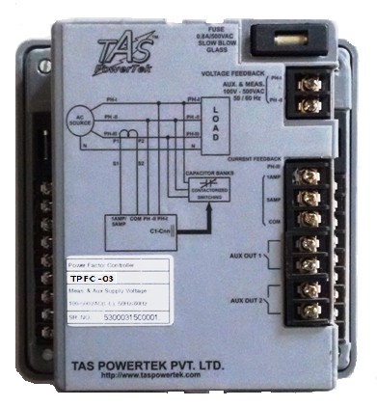

Common Fuse, for Banks C1 to C8, Fast-Blow, 0.2A, 240V AC.

Auxiliary and Measurement supply voltage 100V-500VAC 50 Hz / 60 Hz

10011100

Common Fuse, for Banks C9 to C16, Fast-Blow, 0.2A, 240V AC.

Banks C1 to C8.

Banks C9 to C16.

Auxiliary Digital Output 2, N.O. Relay Contact

Auxiliary Digital Output 1, N.O. Relay Contact

LEFT and RIGHT SIDE Terminal View:

As observed from rear side:

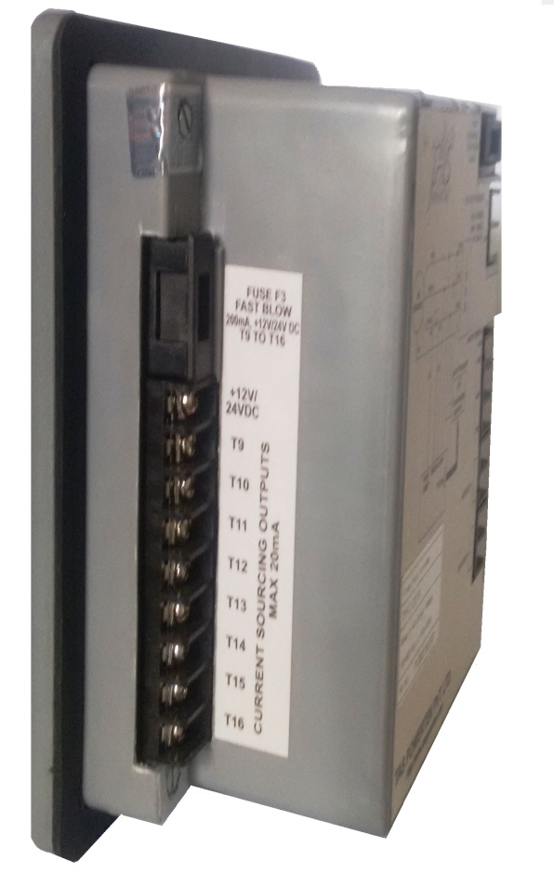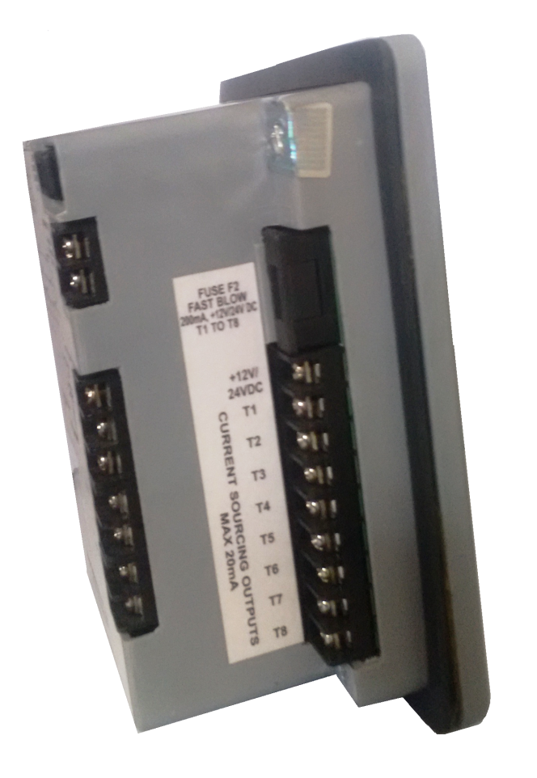

**Left side terminal Rear-View Right side terminal Rear-View**

**INPUT AND OUTPUT CONNECTOR DETAILS:**

***Auxiliary Supply and Measurement Supply****:*

Auxiliary supply and measurement supply have common terminal.

Terminals are marked with PH1 & PH2.

An Auxiliary Input supply is for powering the internal SMPS.

*Measurement supply* is for measuring the Phase-to-Neutral voltage or Phase-to-Phase Voltage, in case of EXPERT Configuration as applicable for the TPFC-03 Controller Unit.

***Mains CT load current feedback Terminals.:***

Terminals are marked with COM, 5 AMP & 1 AMP. These are connected to secondary of the Mains (Load) current feedback CT secondary. The rated secondary can be either nominal 5Amp or 1Amp AC.

In view of the same, the user can use the feedback CT connections appropriately.

COM is the common terminal of CT (common to 5 Amp or 1 Amp).

* If the CT used is with 5 Amp secondary rated value then use the second terminal (5 AMP) with COM terminal of the unit.
* If the CT used is with 1 Amp secondary rated value, use the second CT terminal (1 AMP) with COM terminal of the unit.

Please refer to the terminal arrangement which is shown previously in the back side terminal view.

***On/Off Command Output Terminals:***

Terminals marked with C1 ----- C*nn* and COM.

COM: This is the Common terminal. The DC Voltage applied to this terminal would appear at the output terminals C*nn* if output Current-Sourcing Transistor is turned ON.

*Cnn*: These are the Bank On / Off command terminals. When a specific capacitor bank is to be turned on, it connects the Current-Sourcing Transistor (acting as a switch ) to the COM terminal.

External +12V/+24VDC voltage is given to COM terminal. The C*nn* terminals are connected to Command input Terminal of Thyristor Switch. The other terminal of Thyristor Switch Command is connected to Power Supply 0 Volts Return (Ground) as a Common Return Terminal. The Current-Sourcing Transistor Outputs are current-limited to approximately 20 milli-Amps for compatibility with most Thyristor Switches for Capacitor Bank Switching, including those of TAS.

Please refer the further connection diagrams on relevant pages, for the terminal connection detail.

***Auxiliary Digital Outputs (Two Channels):***

These are marked as AUX OUT 1 and AUX OUT 2. These are provided for inter-locking with external master controllers such as PLC, Alarm annunciation or equivalent.

These are potential-free Normally Open (N.O.) Relay Contacts. Contact Rating is 250Vac at 0.5Amp resistive or inductive load.

Auxiliary output is user programmable to become “Close” (N.C.) due to any of the following:

1. PF controller tripping off capacitor banks on any fault.
2. Over-Temperature (Internal to TPFC-03 unit). For triggering external cooling fan connection.
3. “Out of Capacitor Banks” (Insufficient Total Capacitive kVAr – not able to attain target PF).

**FRONT PANEL INDICATIONS AND KEY-BOARD:**

“I AM OK” LED

LCD DISPLAY



KEYBOARD

**KEY-BOARD DESCRIPTION**:

SOFT-TOUCH KEY-PAD:

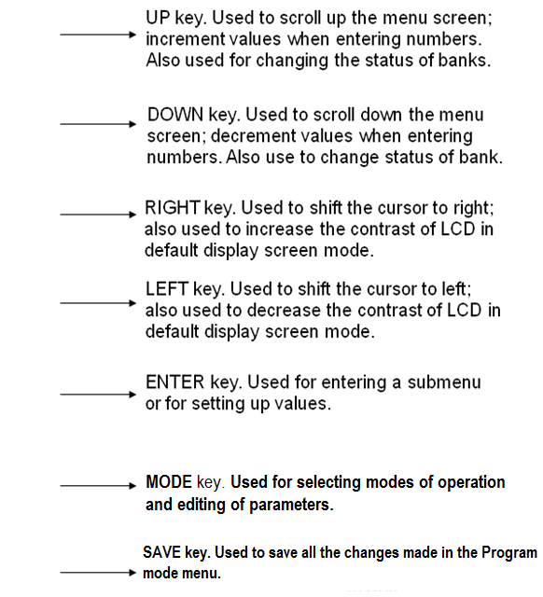



**INSTALLATION CONTROL SCHEMATIC:**

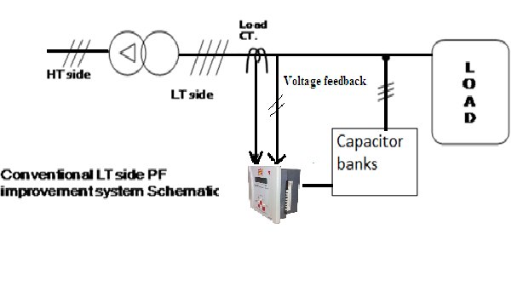

* As per this scheme, the load current sensing CT is put between the AC Power Source and the PF Correction Capacitor banks and load. This is as per the diagram shown above. The positioning of the Load Current sensing CT in the Power Connection diagram is extremely important.
* The Measurement Voltage feedback is taken from the LT Bus System itself. Please note that the Measurement Voltage Feedback is to be taken from the point after the Load sensing C.T.
* This is the most common and conventional scheme.

**INSTALLATION CONTROL SCHEMATIC:**

V & I Feedback control wiring: Typical schematic:



In-Phase Connection (Expert Mode Configuration)

The In-Phase Connection, one phase and neutral is used for voltage monitoring. The load current monitoring CT too is put in the same phase.

**INSTALLATION CONTROL SCHEMATIC (DETAILED):**

Typical Scheme of TPFC-03 with Current-Sourcing Transistor Outputs as

Solid-State Switches:



**The above TPFC-03 connections are shown for Quadrature mode operation.**

In Quadrature Connection, use any two phases for voltage monitoring and use the third phase for the load current monitoring.

**PF CORRECTION TECHNIQUES**

**With Lagging (Inductive) Target Power Factor**

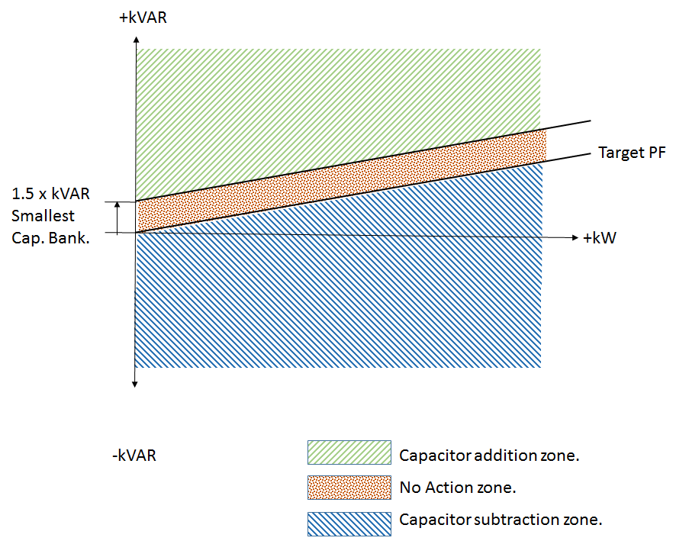

**With Leading (Capacitive) Target Power Factor**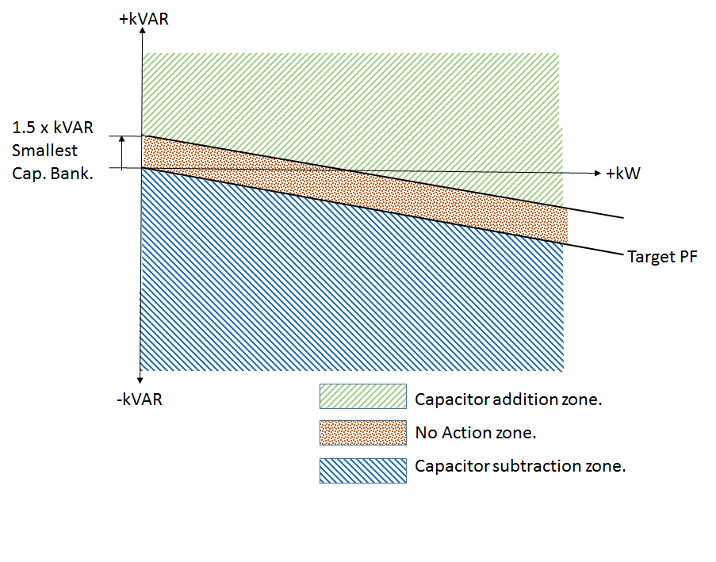

**With Unity Target Power Factor**

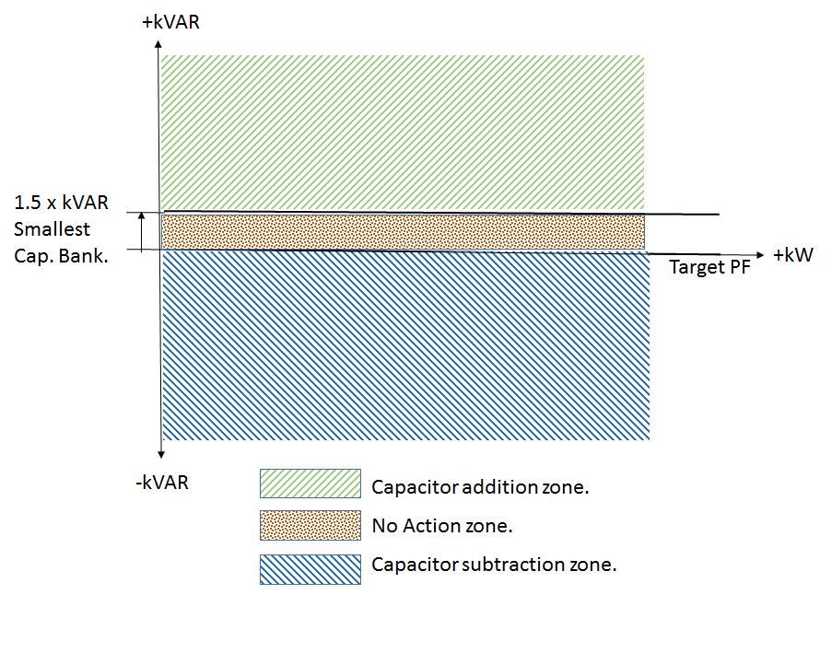

All the three conditions are specified in the diagram. One should take note of “No Action Zone” which is internally created to prevent hunting of the capacitor bank(s), which is, switching ON and OFF every correction cycle.

This PF Controller is designed for a single “TARGET P.F.”

“No Action Zone” is preset to minimum kVAr Capacitor Bank size equal to smallest bank kVAr * 1.5. This band is 50%-50% distributed around the Target PF line. This band size normally takes care of all the variations in supply voltage, frequency and harmonics changes, against the hunting of the Capacitor Banks.

**FRONT LCD DISPLAY:**

* On powering up the unit, there is power on discharge time given for the capacitors to discharge completely. However, if the user is sure that the capacitors are discharged, then on pressing the

**left key** would allow the controller to come out of the discharge time and thus user need not wait for the discharge time to get complete and thus saves time.

* The contrast of the LCD can be adjusted by using the keys. or

The left key will make the contrast darker and right key will make it lighter.

Multiple continuous operations of these keys will achieve this.

* The front LCD Display under default condition displays the various parameter readings.

There are number of screens that show the various parameters that are measured or derived.

These various screens can be displayed by pressing the Scroll keys.

Viz.

UP key -

DOWN key -

Power-up Display Screen. (Only for first 1 second)

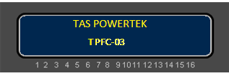

Then the unit should display:

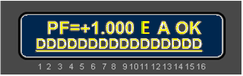

This is the factory set default screen. The “PF=” part is to indicate that the value following that is “Power Factor”. This indicates the PF that is sensed by the Unit near the load current sensing CT position. i.e., the transformer/ supply grid side.

The PF is with “+” OR “­­–­” sign. + Sign indicates Power Factor is lagging and – sign indicates Power Factor is leading. Refer Indian Standard IS 14697: 1999, for Direction and Sign of Active & Reactive Power, PF, Annex F (Clause 3.1.8), for interpretations for a Four-Quadrant Operation of PF Controller.

The next character indicates the “configuration”, i.e.in which configuration the controller is operating.

Viz., **E**xpert Configuration indicated by “**E**”.

The next character on the upper line of display shows the operational mode. There are two modes. Viz. Auto mode indicated by a letter “**A**” and Manual mode indicated by a letter “**M**”.

The last 2 characters on the upper line of display show the Health status of TPFC-03. **OK** indicates that all conditions are fine for normal operation.

“I AM OK” (Health Monitor) LED flashing (Amber colour LED) indicates the controller health status is Healthy.

This LED is located at the extreme, right-hand side, on the top of the front panel, enclosed by a heart shape as viewed by the user.

The last two characters represent the following status:

|  |  |
| --- | --- |
| OK | Controller status is okay |
| OV | Over-Voltage Fault |
| UV | Under-Voltage Fault |
| VH | Voltage Harmonics High Fault |
| IH | Current Harmonics High Fault |
| OT | Over-Temperature (inside TPFC-03 unit) |
| OB | Out of Banks (Insufficient Total Capacitive kVAr) |
| OF | Over-Frequency Fault |
| UF | Under-Frequency Fault |

The bottom line of the LCD display shows the capacitor bank status. The numbers 1 to 16 below the LCD display are for specific outputs (Capacitor bank number that is controlled by TPFC-03).The LCD display above this number gives the status of that specific output/Capacitor bank.

**During Power Up, till the time all Banks are showing D status, the keyboard would not be operational. This is to ensure that at Power-up, all the Capacitors are allowed to be discharged.**

Total blank indicates that the output is not used for control.

A small dash indicates that Bank is connected but is in OFF state.

A symbol indicates that bank is connected and it is in ON state.

A symbol indicates that bank is declared as fixed bank and is ON.

A symbol indicates that bank is declared faulty and is OFF.

**D**

A symbol indicates that bank has just turned off and it is discharging.

**Menu Structure:**

***Expert Configuration menu:***

In this menu, all the parameters are user settable. Only a technical person well conversant with electrical engineering and power factor correction should enter into this configuration. All the values of the parameters are displayed on the LCD in their absolute engineering units.

**PF = + 0.998 E A OK**

**– – – – – – – – – – – – – – – –**

**SELECT (EXPERT)**

**1. PROGRAM MODE**

**SELECT (EXPERT)**

**2. AUTO MODE**

**SELECT (EXPERT)**

**3. MANUAL MODE**

**SELECT (EXPERT)**

**4. TEST MODE**

#

**#**

General parameters

Grid/transformer/APFC system related parameters

Capacitor bank step settings

Fault trip settings

**SELECT (EXPERT)**

**2. AUTO MODE**

**SELECT (EXPERT)**

**3. MANUAL MODE**

**#**

**ENT PRG PWD:**

**\*\*\*\***

**PF = + 0.998 E M OK**

**– – – – – – – – – –**

**SELECT (EXPERT)**

**1. PROGRAM MODE**

Operation in Manual mode

Operation in Auto mode

**PROGRAM MODE**

**FAULTS**

**PROGRAM MODE**

**STEP**

**PROGRAM MODE**

**SYSTEM**

**PROGRAM MODE**

**GENERAL AND IO**

**PF = + 0.998 E A OK**

**– – – – – – – – – –**

**#**

**SELECT (EXPERT)**

**4. TEST MODE**

**VOLT MEAS MODE**

**L-L :**

**\***

**RATED SUPPLY VTG**

**(L-L) : 0440.0V**

SAVE

**d P HASE 1 :**

**SELECTPHASE**

**SAVE**

**PHASE POLARITY**

**POSITIVE :**

**SELECTED PH KW**

**-000323.9**

**#**

**SELECTED PHKVAR**

**-000095.5**

Entering in the TEST Mode of Expert Configuration menu allows the user to carry out synchronization manually. For this, first select the mode of operation, Line-to-Neutral (In-Phase) or Line–to-Line (Quadrature) Mode. After that, the next screen is the selection of Phase. According to the selected phase, the user can see all the kW and kVAr values of the selected phase for getting judgement of right selection of Phase sequence & polarity. After selection, Save key is to be pressed.

**#**

**\***

**STEPS CONNECTED**

**: 04**

**BANK [1]**

**KVAr: 00000 : 06**



**This SAVE command saves all the edited parameters in the TEST mode. Controller runs on the right sequence by manual synchronization.**

**BANK [2]**

**KVAr: 00000 : 06**

**BANK [3]**

**KVAr: 00000 : 06**

**BANK [4]**

**KVAr: 00000 : 06**

All the Capacitor Bank kVAr values are to be fed in the Controller in their absolute value. kW and kVAr values can be seen in their absolute engineering units.

**Editing the user defined parameters**

* **MODE PASSWORD** is basically for changing the mode. The 4-digit number that can act as a pass-word can be changed by changing the value in this parameter.
* **PROGRAM PASSWORD** is for entering into the Program mode parameters in Expert mode menu. Only trained person should enter into this mode and edit the values. Program default password is 0002.
* **LOAD DEFAULT**: There are number of parameters that are loaded at the time of manufacturing. In case, if the user wishes to put these values, the **Load default** can be put to “Yes” and then “Save” command would put the all parameters as set while manufacturing.
* **AUX OP1 FUNCTION**: Program the auxiliary digital output to become NC due to any of the following choices: NONE, TRIP FLT, OVER TEMP, OUT OF BANK
* **AUX OP2 FUNCTION**: Same as above (As aux. digital output 1 function)

**Note**: The auxiliary digital output 1 and auxiliary digital output 2 functions are of auto reset types.

**PROGRAM MODE**

**GENERAL AND IO**

AUX OP1 FUNCTION:

TRIP FLT:

AUX OP2 FUNCTION:

OVER TEMP:

LOAD DEFAULT:

No :

PROGRAM PASSWORD:

: 0002

**PROGRAM MODE**

**SYSTEM**

PF TARGET

[Ind: 1] 0.999

CT RATIO PRIMARY

: 1000

PF TARGET[Ind: 1] 0.999

* **VOLT MEAS MODE**: This is the system parameter that defines the controller’s connections of operation (auxiliary supply to the controller). These are two types:

Line-to-Line (Quadrature) and Line-to-Neutral (In-Phase) Modes.

* **RATED SUPPLY VTG**: This is the system parameter that defines the controller’s nominal supply voltage. These are edited as per the Quadrature or In-Phase mode select:

Line-to-Line (Quadrature) and Line-to-Neutral (In-Phase).

* **CT RATIO PRIMARY**: This parameter tells the controller about the primary current rating of the grid/transformer side connected CT.
* **PF TARGET**: User can set the target PF as Inductive: 1 or Capacitive: 0.
* **PF TARGET**: The exact value can be set here. User can set the value anywhere in between 0.700 to 1.000.

VOLT MEAS MODE

L-L :

RATED SUPPLY VTG

(L-L) : 0415.0V

**Fast off action**: In this, all the banks that are switched ON, are tripped at one go.

* **OVER VOLTAGE FAULT**: This would indicate the over voltage fault, if “Fast off” option is activated. It has two options: Disable and Fast off.
* **OVER VOLTAGE LIMIT**: This screen would be visible only if the above screen, i.e. the over voltage fault parameter is set to “Fast off”. In this, user can set the limit in percentage and if the voltage exceeds this limit then “OV” fault would be indicated on the LCD display and corrective action is taken.
* **UNDER VOLTAGE FAULT**: This would indicate the under voltage fault, if “Fast off” option is activated. It has two options: Disable and Fast off.
* **UNDER VOLTAGE LIMIT**: This screen would be visible only if the above screen, i.e. the under voltage fault parameter is set to “Fast off”. In this, user can set the limit in percentage and if the voltage falls below this limit then “UV” fault would be indicated on the LCD display and corrective action is taken.
* **TEMPERATURE FAULT**: This has two options: Disable and Fast off.
* **TEMPERATURE LIMIT**: This screen would be visible only if the above screen, i.e. the temperature fault parameter is set to “Fast off”. User can set the limit and if the APFC unit internal temperature exceeds this limit, “OT” fault would be indicated on the LCD and corrective action is taken to turn off all Banks.
* **HARMONIC OVERLOAD**: This has two options: Disable and Enable. If this parameter is enabled, then only the below three screens would get displayed.
* **V-THD THRESHOLD**: Total voltage harmonic distortion limit can be set in this menu. User can set the limits in percentage. If the percentage value of total voltage harmonics distortion (V-THD) exceeds the set limit, then “VH” fault would be indicated on the LCD display.
* **I-THD THRESHOLD**: Total Current harmonic distortion limit can be set in this menu .User can set the limits in percentage. If the percentage value of total current harmonics distortion (I-THD) exceeds the set limit, then “IH” fault would be indicated on the LCD display.

**PROGRAM MODE**

**FAULT**

I-THD THRESHOLD

LIMIT(%) : 025

V-THD THRESHOLD

LIMIT(%) : 05

HARMONIC OVRLOAD

Enable :



**IF ENABLE**

**IF DISABLE**

**IF DISABLE**

**IF DISABLED**

**IF FAST OFF**

**IF FAST OFF**

**IF FAST OFF**

OVER VOL FAULT

Fast Off:

UNDER VOLTAGE LIMIT (%) : 085

TEMPERATURE

LIMIT : 60

TEMPERATURE FLT

Fast Off:

UNDER VOL FAULT

Fast Off:

OVER VOLTAGE

LIMIT (%) : 110

**#**

#

* **HARMONIC FAULT AUTO RESET**: This has two options, namely Disable and Enable. If this screen is set for enabled, then the harmonic fault is auto reset after 180 seconds.

HAR FLT AUTO-RST

Enable :

* **STEP HEALTH CHECK**: TPFC-03 carries out on line monitoring of the kVAr values of every Bank. This is when the Bank is put in the circuit. In case the tolerance limit defined here is exceeded, that specific bank is declared faulty. If step health check is enabled, then only its bank tolerance limit screen would be visible

STEP HEALTH CHK

Disable :

OUT OF BANKS FLT

Enable :

* **OUT OF BANKS FAULT**: This is only with Disable and Enable (Indicative option). If on 1, then Unit will indicate this fault as “OB” if PF is inductive beyond set target PF compensation range and all the healthy capacitor banks are in ON state.

i.e., Total kVAr Capacity of the Capacitor bank steps is

lesser than the load kVAr requirement.

**If this option is enabled, then only this fault can be assigned to auxiliary digital output 1 or auxiliary digital output 2, for indication to external system**

* **CORRECTION TIME**: Defined in terms of Line Frequency Cycles. This is the time between two consecutive kVAr compensations. During this time in case any Key is pressed on the controller , the correction time is reset & again starts from zero.
* **DISCHARGE TIME**: Time defined here is the time in seconds for discharge of the capacitor banks to a level, so that this Capacitor Bank can be turned ON again, at the end of discharge time.
* **INTERLEAVING TIME**: This is the switching delay between two banks execution. User can set it as instantaneous, or one second as the only other option.
* **SMALLEST kVAr:**  This multiplying factor defines the “no action zone” prohibiting the capacitor bank On/Off operation to avoid hunting. It can be set from 1.1 to 1.9. The factory default value is 1.5.
* **COMPENSATION BAND OFFSET :** This band is

normally 50%-50% distributed around the

Target PF line. This band size normally takes

care of all the variations in supply voltage,

line frequency and harmonics changes, against the

hunting of the Capacitor Banks. The band can

be set from 0% to 100%. The factory default

value is 50%.

* **STEPS CONNECTED**: Defines the total number of Capacitor Bank Steps operational. Depending on PF system banks, this parameter is set.
* **FIX-BANK SETTING**: Defines the banks that are to be declared as fixed. These banks, even in spite of overcompensation, cannot be turned OFF. The banks can only be turned OFF under certain fault conditions.
* **CAP BANK VOLTAGE**: Defines the capacitor banks voltage at which the bank kVAr value is defined.

* **BANK kVAr [1….16]**: In TPFC-03, every bank kVAr is to be defined at rated Voltage. TPFC-03 has an in-built intelligent algorithm to select the best possible combination to suit the exact kVAr requirement for compensation.

COMP Band offset

in % : 050

Smallest Kvar

Safety Factor : 1..5

STEPS CONNECTED

: 16

FIX-BANK SETTING

_ _ _ _ _ _ _ _ ­_ _ _ _ _

CAP BANK VOLTAGE

(L-L) : 00440 V

BANK [1]

KVAr : 00001

IntrLeavingDely

INST:

DischargeTime

SECONDS :00010

Correction Time

Cycles : 00050

**PROGRAM MODE**

**STEP**

**Display of various parameters:**

Values of various parameters can be viewed by the UP/DOWN key and then pressing the ENTER key. To exit a sub-menu, press MODE key.

* **MAIN SCREEN**: This is factory set default screen giving indication of PF, functionality mode, operating mode and APFC system status.
* **MEASURED VALUES:** give the measured values of the system parameters like V, I, kW, kVAr, kVA and frequency.
* **MAX VALUES**: gives the maximum values of V, I, kW, kVAr and kVA, detected after the last reset. This also has the facility of resetting the maximum values manually which would be the actual instantaneous values and not zero.
* **Display THD:** THD% for voltage and load current. Also displays odd harmonics up to 15th.
* **DISPLAY STEP:** the measured kVAr values of each connected output capacitor bank step.
* **DISPLAY AUX. FUN:** the APFC unit’s internal temperature, status and selection of auxiliary output.
* **DISPLAY UTILIZATION CNTR:** the bank utilization counter, i.e. Time duration the bank is utilized and also displays the clear bank counter to 0. This helps in proper maintenance of the Three-Phase Power Capacitor-Duty Thyristor switches
* **DISPLAY SR NO:** the unique serial number of the particular APFC controller.
* **DISPLAY UNIT DETAILS:** the name and version of software. The firmware version number may be different dependent on date of design update(s).

**PF = +0.999 E A OK**

**_ _ _ _ _ _ _ _ _ _ _ _ _ _ _ _**

___

**DISPLAY**

**MEASURED VALUES**

___

**DISPLAY**

**MAX VALUES**

___

**DISPLAY**

**HARMONICS**

___

**DISPLAY**

**STEP KVAR**

___

**DISPLAY**

**AUX - FUNCTION**

___

**DISPLAY**

**UTILIZATION CNTR**

___

**SERIAL NUMBER**

**1234567890123**

___

**TAS POWERTEK**

**VER. 1.0.3**

___

**Sub-menu for display of parameters in Expert configuration:**

|  |  |  |  |  |  |
| --- | --- | --- | --- | --- | --- |
| **MEASURED**  **VALUES** | **MAX VALUES** | **HARMONICS** | **STEP kVAr** | **DISPLAY**  **AUX-FUNCTION** | **DISPLAY**  **UTILIZATION CNTR** |
| MEASURED  VOLTAGE | MAX_VOLTAGE | V-THD-F | STEP[01]KVAr | AUX OP1: TRIP FLT | UTILIZATION  CNTR |
| 00415.0V(L-L) | 0000.0 V | 000.0% | 0001.0 | STATUS: 0 | BANK[1]:000000 |
| MEASURED  CURRENT | MAX_CURRENT | I-THD-F | **.** | AUX OP2: OVR TEMP | **.** |
| 1000.5A | 0000.0 A | 000.0% | **.** | STATUS: 0 | **.** |
| ACTIVE  POWER | MAX_KW |  | **.** | INT-TEMPERATURE | BANK[16]:000000 |
| 000000.0KW | 0000.0 KW |  | **.** | 28 Deg C | CLR BANK[1] CNTR |
| REACTIVE  POWER | MAX_KVAR |  | STEP[16]KVAr |  | No : |
| 000000.0 KVAr | 0000.0 KVAR |  | 0000.0 |  | **.** |
| APPARENT  POWER | MAX_KVA |  |  |  | **.** |
| 000000.0KVA | 0000.0 KVA |  |  |  | CLR BANK[16] CNTR |
| C- KVAR | RESET  MAX_VALUES |  |  |  | No : |
| 000000.0 | No : |  |  |  |  |
| FREQUENCY |  |  |  |  |  |
| 50.0Hz |  |  |  |  |  |

In Expert configuration, all the values are displayed in their absolute engineering units.

**Auxiliary function** has two auxiliary outputs. It shows the type of the auxiliary output functionality that the user has selected and also LCD Displays its status.

0: Logic “Low” signal (Internal Relay Contact is open, i.e., Relay is in OFF State).

1: Logic “High” signal (Internal Relay contact is closed, i.e., Relay is in ON State).

Harmonic data of various current & voltage parameters can be viewed by pressing ENT on the respective parameter screen of the Harmonics menu. Following are the sub-menus giving the harmonic data of voltage, current.

|  |
| --- |
| **V- Harmonics**  **03rd: 00.0 %** |
| **V - Harmonics**  **05th: 00.0%** |
| **V - Harmonics**  **07th: 00.0 %** |
| **V - Harmonics**  **09th: 00.0%** |
| **V - Harmonics**  **11th: 00.0 %** |
| **V- Harmonics**  **13th: 00.0 %** |
| **V - Harmonics**  **15th: 00.0 %** |

|  |
| --- |
| **I - Harmonics**  **03rd: 00.0 %** |
| **I - Harmonics**  **05th: 00.0%** |
| **I - Harmonics**  **07th: 00.0 %** |
| **I - Harmonics**  **09th: 00.0%** |
| **I - Harmonics**  **11th: 00.0 %** |
| **I - Harmonics**  **13th: 00.0 %** |
| **I - Harmonics**  **15th: 00.0 %** |

**Auto and Manual operation modes:**

This controller has two modes of operation, “Auto” and “Manual”.

**Auto Operation:**

**SELECT (EXPERT)**

**AUTO OPERATION**

On this screen, pressing “ENT” key would put the unit in Auto Operation. This mode would continue till alternate option mode is selected or unit is put in Power down condition.

This is the mode in which the unmanned operation of automatically putting the capacitor bank,, in and out of circuit is performed.

This mode should be normally selected with this controller, once the system is totally commissioned.

Here the kVAr compensation values are calculated by this controller and the closest equivalent capacitor combination is inserted in the system so that the PF is maintained within the desired level. This is as per the kW v/s kVAr graphs shown earlier in PF compensation part.

On the default display, the status of capacitor banks is seen as performed by this controller.

If any capacitor bank is sensed as faulty by this controller, it would mask the said bank and PF relay would search for new nearest value bank combination to maintain the target PF.

When interleaving delay is set to 1-second, capacitor bank turn ON/OFF is performed for two or more successive capacitor switching operation with 1-second delay.

When interleaving delay is set to instantaneous, two or more successive capacitor switching operation takes place simultaneously.

**Manual Operation:**

**SELECT (EXPERT)**

**MANUAL OPERATION**

Pressing “ENT” button on this screen will put the controller in Manual mode. This mode will continue to run till it is purposefully changed or Power down. This mode is normally used to perform the operation like:

* Resetting of faulty banks to healthy status.
* Declaring specific bank/banks faulty. Masking of the banks so that once auto mode is selected, these faulty declared banks would not be used.
* Checking the capacitor banks by turning them ON/OFF.
* While commissioning, all the capacitor banks should be turned ON and should be checked regarding its healthy status.

For Declaring Banks faulty or Resetting faulty banks:

In Manual mode default screen press “ENT”. The cursor above bank-1 will start blinking.

Use  keys to select the specific bank. Then use  key to declare the bank faulty. To reset the faulty bank, bring the blinking cursor to that bank and use key to declare the bank as healthy.

Once the specific banks are declared faulty or reset from faulty to a healthy status, press “ENT” key so that cursor stops blinking.

**Note:** As the primary objective of TPFC-03 is to control PF, it cannot be left in manual mode forever. Therefore, while the Unit is in manual mode and if no key is pressed for two minutes then the TPFC-03 will be automatically switched to AUTO mode of control by putting off all the Capacitor Banks first.

**NOTES:**

1. If current CT connections are not connected to the TPFC-03 Unit i.e., if no current is detected or the detected current is below 0.5% of rated load current, thenTPFC-03 would show the following display on the LCD.

**PF = + ?.??? E A OK**

**– – – – – – – – – – – –**

1. If Harmonics overload fault is enabled, and if the voltage or current THD exceeds the respective set limits, then TPFC-03would flashes the message “ENT TO (MANUAL) RESET” on the LCD display.

PF = + ?.??? E A VH

ENT TO RESET

DDDDDDDD

**PF = + ?.??? E A IH**

**ENT TO RESET**

DDDDDDDD

Pressing the Enter key, would reset the **VH / IH** fault even if voltage / current THD% is above the set limit. The fault indication would continue till the respective THD% is above the set limit. In case of THD% above limit, all capacitor banks are switched off to protect them.

***Commissioning Instructions:***

**Commissioning guidelines- After the panel is powered-up:**

**Expert Mode Configuration**

1. All the MCB’s / MCCB’s for capacitor protection shall be kept in ***OFF*** position.

In case of Fuses remove the fuses in series with every capacitor bank. Connect the supply to the controller. Keep the load current feedback CTs in shorted condition.

1. Turn On the supply to the panel and set various parameters as per the panel configuration. For using Expert mode, it is essential to understand the meaning of every parameter and then put the appropriate values in them. Wrong values entered can give the wrong performance of the panel.
2. Once the parameterization is complete, put the TPFC-03 in Manual mode to check each bank Thyristor switch is operational from TPFC-03. This can be carried out by keeping the control supply to Thyristor switch ON. By checking that on command from TPFC-03 is reaching the specific Thyristor switch ON , by observing their respective ON / OFF operations.
3. Once all the switches are seen to be getting the correct commands, switch off the supply to the panel and replace all the fuses (or turn on MCBs or MCCB’s if they are provided instead of fuses). Turn On the panel.

Put TPFC-03 back in Manual mode and turn ON/Off the individual Bank. Use Current measurement clamp-on meter (ac current measurement) to check that current in all the three phase of the corresponding bank are OK. It should be approximate 1.4 times the kVAr capacity of the capacitor bank step.

1. Keep all the banks in off mode. Remove the shorting of Load Current feedback CT. In case kW value is seen as negative, CT is with wrong polarity. Correct the polarity with proper physical connection. Put the TPFC-03 in Automatic mode. Observe the panel performance for a period of about 2 Hours after the commissioning.

***Fault finding Guidelines and Trouble-shooting procedures***

***Fault finding guidelines:***

|  |  |  |
| --- | --- | --- |
| Fault Type | Probable Reason | Action to Take |
| Unit Does not turn ON. LCD is blank with no Backlight | * Input supply is not coming. * Input side fuse may be blown | * Check the input supply to restore * Check fuses in the unit for OK |
| Unit not turning ON any capacitor banks, immediately after Power on | * This is perfectly OK if unit is powered up, there is a delay of correction time that is provided in the unit only after which units can turn on outputs. However if the user is sure that the capacitors are discharged completely and does not want to wait for the discharge time then user can press the “**left key**” and come out of the discharge time. | * As this is normal action, need not take any specific action. Unit will start performing normally after the stipulated time delay. |
| With capacitor banks ON, TPFC-03 does not indicate the PF as improved. | * Check that Load CT put is in correct phase and on mains source side. * Check if CT secondary terminal selected is 5Amp or 1Amp and check if wrongly wired. | * Correct the wiring as per the scheme requirements and the CT positioning or run auto-synchronization. |
| Thyristor Switch controlled by this unit is/are not turning ON/OFF even if front LCD Display indication shows correct. | * Control wiring to Thyristor Switch is open circuit * Internal fuse at transistor output module blown off due to some momentary very high voltage applied to the Input Terminal. * Check External Power Supply | * Check the continuity for any open circuit. * Replace the externally accessible fuse(s) of the unit. While replacing, make sure that the type and rating is the same. * Replace external 12 Vdc or 24 Vdc Supply if failed. |

**Parameter Settings**: PROGRAMME Mode, In Expert configuration:

|  |  |  |  |
| --- | --- | --- | --- |
| **Parameter** | **Min** | **Max** | **Default** |
| **General IO** |  |  |  |
| Program password (Only for Expert configuration) | 0000 | 9999 | 0002 |
| Load default (Yes/No) | - | - | No |
| Aux OP 1: NONE  TRIP FLT  OVER TEMP  OUT OF BANK | - | - | TRIP FLT |
| Aux OP 2: NONE  TRIP FLT  OVER TEMP  OUT OF BANK | - | - | OVER TEMP |
|  |  |  |  |
| **System** |  |  |  |
| Volt meas. Mode  (L-N/L-L) | - | - | L-L |
| Rated Supply Vtg(L-L)  (L-N) | 110  110 | 500  288.5 | 415  240 |
| CT ratio | 1 | 6500 | 1000 |
| PF Target (Ind/Cap) | - | - | Ind |
| PF Target | 0.700 | 0.999 | 0.999 |
|  |  |  |  |
| **Faults** |  |  |  |
| Over voltage fault  (Disable / Fast Off) | - | - | Fast Off |
| Over voltage limit (%) | 105 | 125 | 110 |
| Under voltage fault  (Fast Off/Disable) | - | - | Fast Off |
| Under voltage limit (%) | 70 | 95 | 85 |
| Temperature fault  (Fast Off/Disable) | - | - | Fast Off |
| Temperature limit (Deg-Celsius) | 50 | 65 | 60 |
| Harmonic overload(Enable/Disable) | - | - | Enable |
| V-THD threshold limit (%) | 1 | 20 | 5 |

|  |  |  |  |
| --- | --- | --- | --- |
| I-THD threshold limit (%) | 3 | 150 | 25 |
| Harmonic Fault Reset(Enable/Disable) | - | - | Enable |
| Step health check(Enable/Disable) | - | - | Disable |
| Bank kVAr fault tolerance (% of rated) | 3 | 50 | 20 |
| Out of Bank (Enable/Disable) | - | - | Enable |
| **Step** |  |  |  |
| Correction time (cycles) | 3 | 3000 | 120 |
| Discharge time (seconds) | 1 | 60 | 60 |
| Interleaving dely (0=instant/ 1= 1sec) | 0 | 1 | 0 |
| Smallest KVAR safety Factor | 1.1 | 1.9 | 1.5 |
| Compensation Band Offset in % | 000 | 100 | 050 |
| Steps connected | 1 | 16 | 16 |
| Fix bank setting | 1 | 16 | 16 |
| CAP Bank Voltage (L-L) | 110 | 600 | 440 |
| Bank kVAr[1] …. [16] | 1 | 65535 | - |

|  |  |
| --- | --- |
| **FAULT** | **FAULT ACTION** |
| Over voltage (OV) | Fast OFF (All banks simultaneously off) |
| Under voltage (UV) | Fast OFF (All banks simultaneously off) |
| Over temperature (OT) | Fast OFF (All banks simultaneously off) |
| Voltage harmonics (VH) | Normal banks + Fixed banks OFF, one bank off at a time |
| Current harmonics (IH) | Normal banks + Fixed banks OFF, one bank off at a time |
| Out of Bank (OB) | Due to insufficient Total Capacitor Banks, requirement of kVAr is not satisfied. |

Action of Fast-off during fault means all banks are simultaneously turned off. For others, only one bank is turned off at a time.

**Note:** The Measurement Voltage Feedback Potential Transformer (PT) ratio is internally set as 1:1 (primary: secondary).

**Field Commissioning & Set-up Records for the Specific Project Site Use:**

|  |  |  |  |
| --- | --- | --- | --- |
| **Parameter** | As on date | As on date | As on date |
| **General IO** |  |  |  |
| Program password |  |  |  |
| Load default (Yes:1/No:0) |  |  |  |
| Aux OP 1: NONE  TRIP FLT  OVER TEMP  OUT OF BANK |  |  |  |
| Aux OP 2: NONE  TRIP FLT  OVER TEMP  OUT OF BANK |  |  |  |
|  |  |  |  |
| **System** |  |  |  |
| Volt meas. Mode  (L-N/L-L) |  |  |  |
| Rated Supply Vtg (L-L) / (L-N) |  |  |  |
| CT ratio |  |  |  |
| PF Target (Ind/Cap) |  |  |  |
| PF Target |  |  |  |
|  |  |  |  |
| **Faults** |  |  |  |
| Over voltage fault  (Fast Off/Disable) |  |  |  |
| Over voltage limit (%) |  |  |  |
| Under voltage fault  (Fast off /Disable) |  |  |  |
| Under voltage limit (%) |  |  |  |
| Temperature fault  (Fast off /Disable) |  |  |  |
| Temperature limit (%) |  |  |  |
| Harmonic overload(Enable/Disable) |  |  |  |
| V-THD threshold limit (%) |  |  |  |

|  |  |  |  |
| --- | --- | --- | --- |
| I-THD threshold limit (%) |  |  |  |
| Harmonic Fault Auto Reset(Enable/Disable) |  |  |  |
| Harmonic Fault Reset (Timer) |  |  |  |
| Step health check(Enable/Disable) |  |  |  |
| Bank kVAr fault tolerance |  |  |  |
| Out of Bank (Enable/Disable) |  |  |  |
| **Step** | As on Date | As on Date | As on Date |
| Correction time (cycles) |  |  |  |
| Discharge time (seconds) |  |  |  |
| Interleaving delay |  |  |  |
| Smallest KVAR safety Factor |  |  |  |
| Compensation Band Offset in % |  |  |  |
| Banks connected |  |  |  |
| Fix bank setting |  |  |  |
| CAP Bank Voltage (L-L) |  |  |  |
| Bank kVAr [1] |  |  |  |
| Bank kVAr [2] |  |  |  |
| Bank kVAr [3] |  |  |  |
| Bank kVAr [4] |  |  |  |
| Bank kVAr [5] |  |  |  |
| Bank kVAr [6] |  |  |  |
| Bank kVAr [7] |  |  |  |
| Bank kVAr [8] |  |  |  |
| Bank kVAr [9] |  |  |  |
| Bank kVAr [10] |  |  |  |
| Bank kVAr [11] |  |  |  |
| Bank kVAr [12] |  |  |  |
| Bank kVAr [13] |  |  |  |
| Bank kVAr [14] |  |  |  |
| Bank kVAr [15] |  |  |  |
| Bank kVAr [16] |  |  |  |

**Contact us:**

The Sales & Marketing / The Customer Support & Service Dept.,

**TAS PowerTek Pvt. Ltd.,** W-61, C/o. Pawar Industries, Opp. “Machine House”,

MIDC Industrial Area, Ambad, **Nasik – 422 010 (via Mumbai)**

Maharashtra State, India.

Land-Line Phones: +0091-253-6694956 (Sales & Marketing)

+0091-253-6694955 (Customer Support & Service)

Fax: +0091-253-6694 955

Working Hours: 9:30 AM to 6:30 PM Normal Weekly Off: Saturdays

E-mail: [sales@taspowertek.com](mailto:sales@taspowertek.com) Web: [www.taspowertek.com](http://www.taspowertek.com/)

**This Product is completely Designed, Developed, Manufactured, Assembled, Tested and Calibrated in India by:**

**TAS PowerTek Pvt. Ltd., Nasik – 422 010, India**



**Would you like to learn in-depth on the subject, then, buy e-Book on-line from Amazon.com**

**Book Title: Reactive Power Compensation on LV Supply.**

**Author: Mr. Tushar P. Mogre, CEO, Director, TAS PowerTek Pvt. Ltd.**

**e-Book Published by: Amazon.com**

**Web link:** [**http://www.amazon.com/gp/aw/d/B00o7YLLYY**](http://www.amazon.com/gp/aw/d/B00o7YLLYY)

